Soil Moisture Project Website User’s Guide

Introduction

The purpose of this project was to provide the researchers on the USGS / Geography Discipline / Land Remote Sensing Program research project entitled “A Method of Determining Soil Water Content from Remotely Sensed Data” a place to easily catalogue meta-data about the images they are collecting for this project, as well as post progress reports or other project updates.

Site Layout

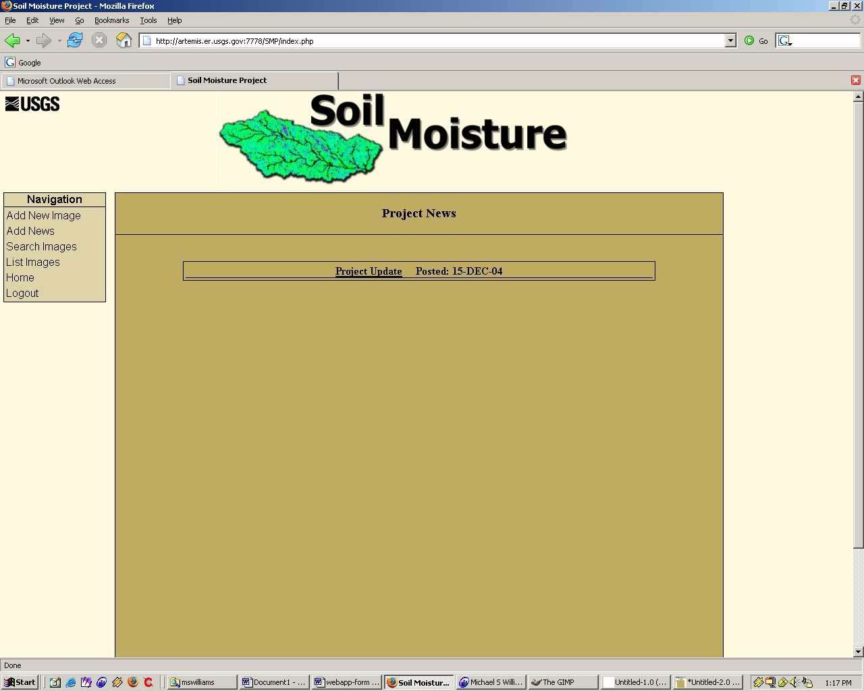
As can be seen from the screen capture, the layout of the site is fairly standard; the navigation bar on the left has links to all the different areas of the site, and all content is displayed in the main content area.

Adding New Image Data

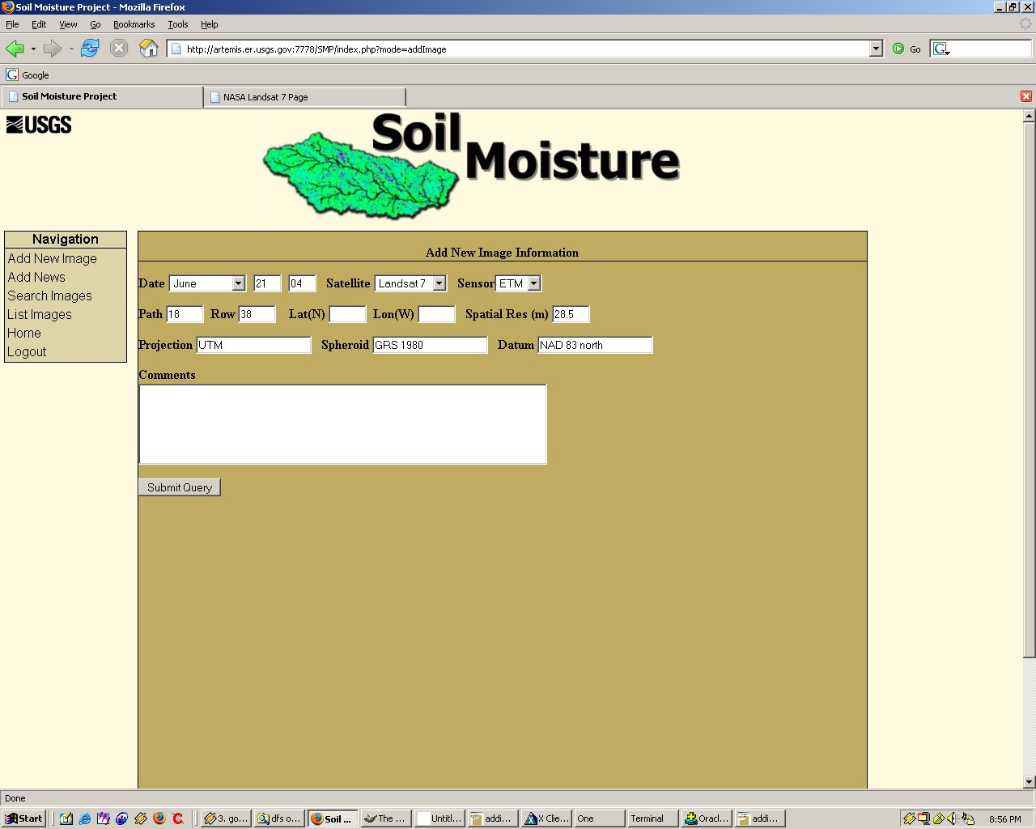
The image data entry screen is fairly straightforward. All the user has to do is fill in the appropriate fields and click “submit” and the data will be added to the database. Only four of the above fields are required to enter an image: the date (month, day, and year), the satellite and sensor, and the spatial resolution of the image; all other data is optional. It is important to note, however, that if you choose to enter path/row or lat/lon values you HAVE to enter both values associated with each. For example, you cannot enter a value for longitude, with no accompanying value for latitude.

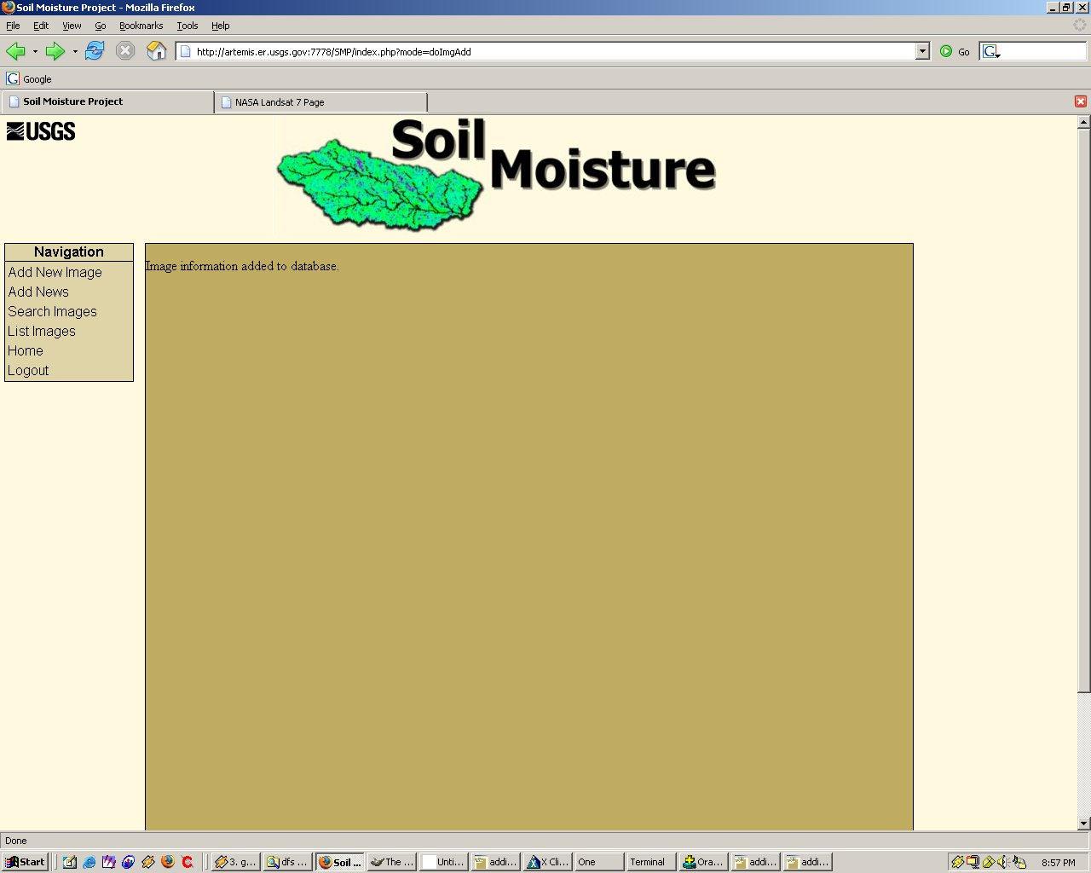

After the image has been added, a confirmation is displayed, then if the user wishes to see the new entry, he/she can click “List Images”.
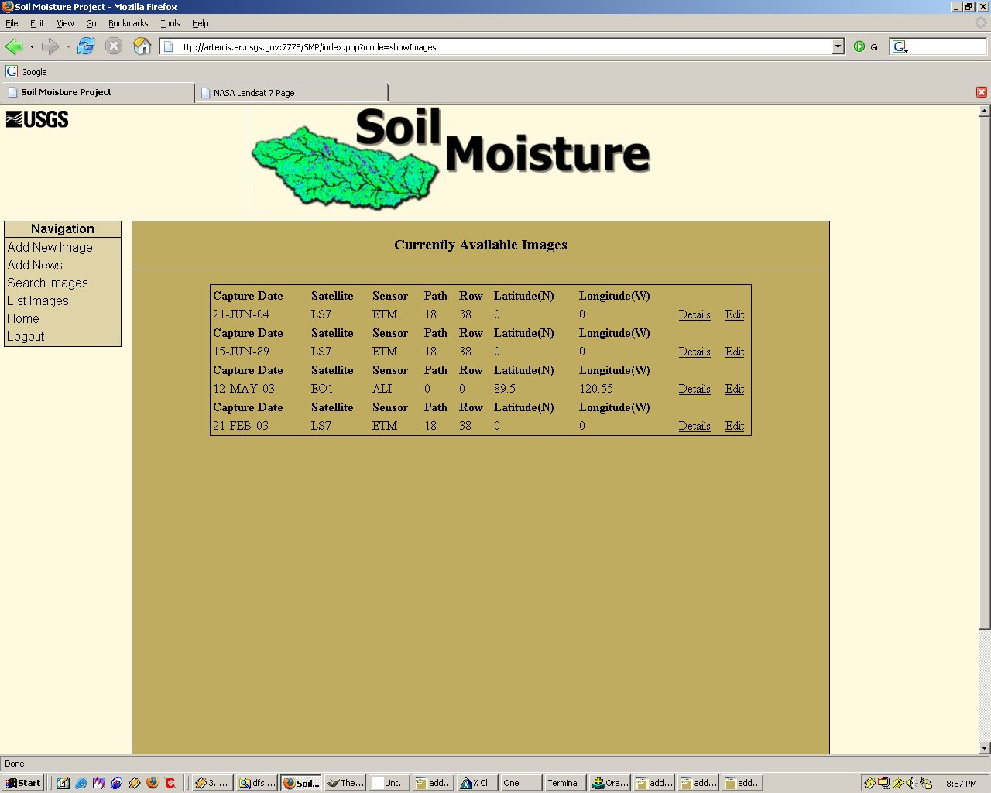

After clicking “List Images” the new image that was added can be seen at the top of the list.

Adding Project News

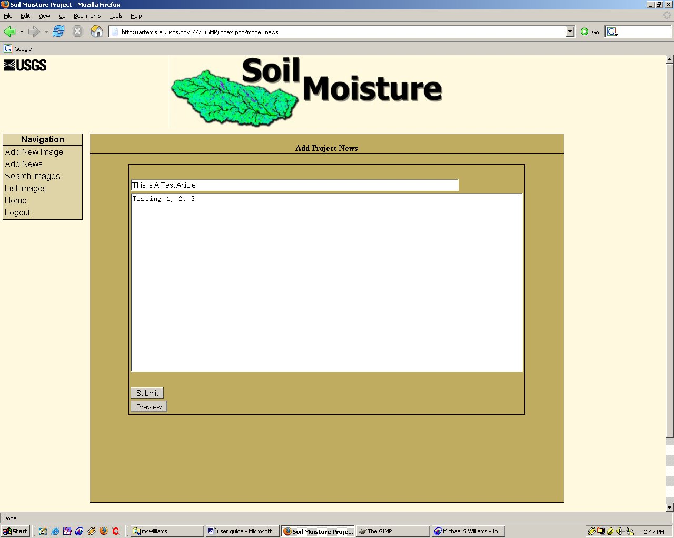

Adding project updates to the site is easy; all the user has to do is type the subject of the update (which will appear on the main page and provide a link to the entire article), and the actual article. If the user wishes, he/she can click “preview” before submitting the article to make sure everything looks as expected, a screen capture of this is shown below.

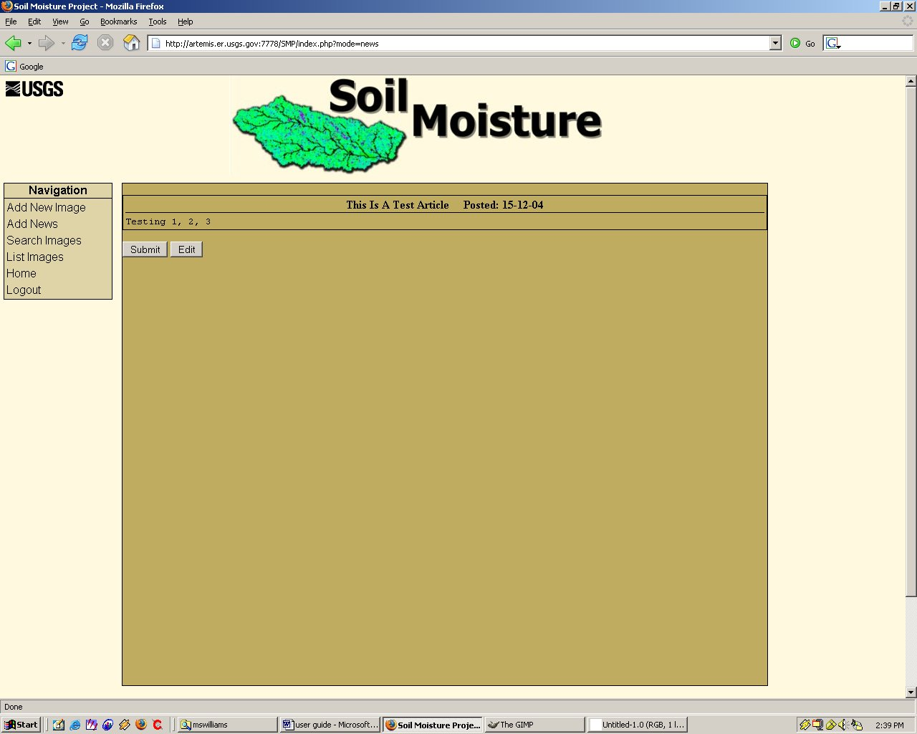

If the user is happy with the way the article looks, he/she can click “submit” to enter the article in to the database, otherwise he/she can click “edit”, which will return to the add news screen so that changes can be made. Once the article is present in the database, it will show up on the main page of the site.

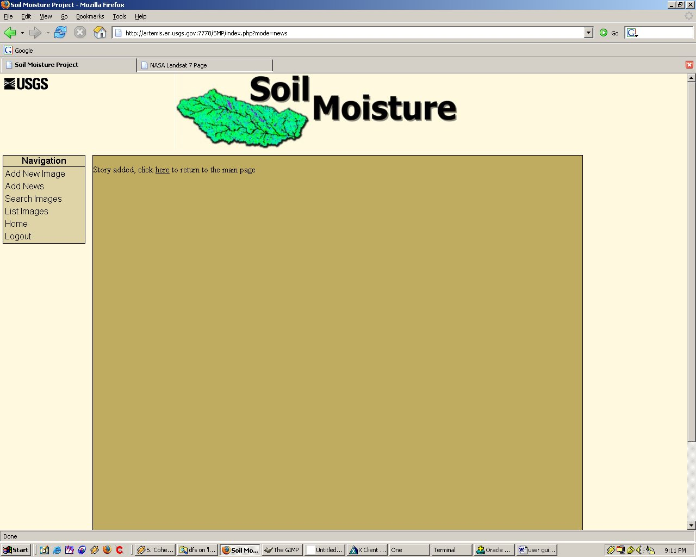

After the user clicks “Submit” a confirmation dialog that includes a link to the newly posted article is displayed for the user.
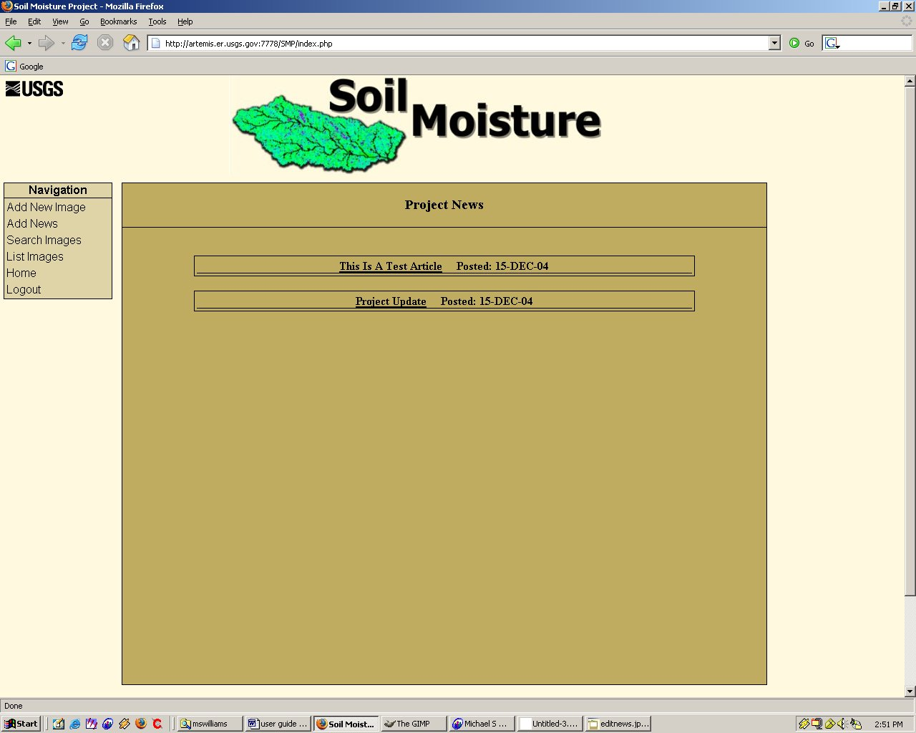

As can be seen from the above screen capture, the newly entered article is displayed at the top of the page, along with the date that it was posted. If the user clicks on the subject link, he/she will be shown the full news article.

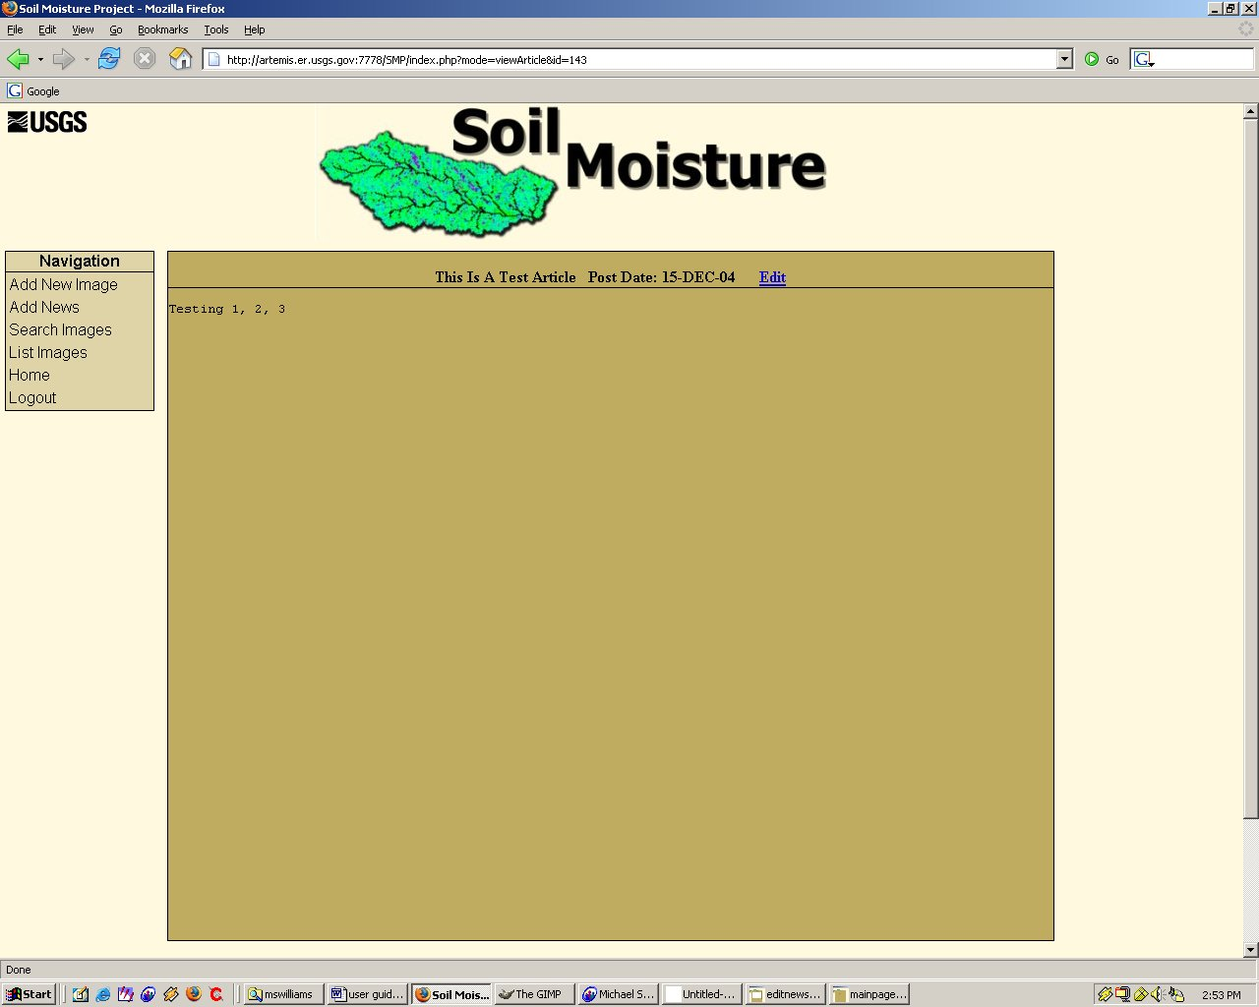

Listing Images

There are two ways for the user to get a list of the image data contained in the database: clicking “list images” or clicking “search. Clicking “list images” will bring up the screen shown above, where every piece of image data currently in the database is listed, starting with the newest entries. If the user sees an image that he/she wishes to examine more closely, he/she can click “Details” to bring up a more detailed description of the image data.

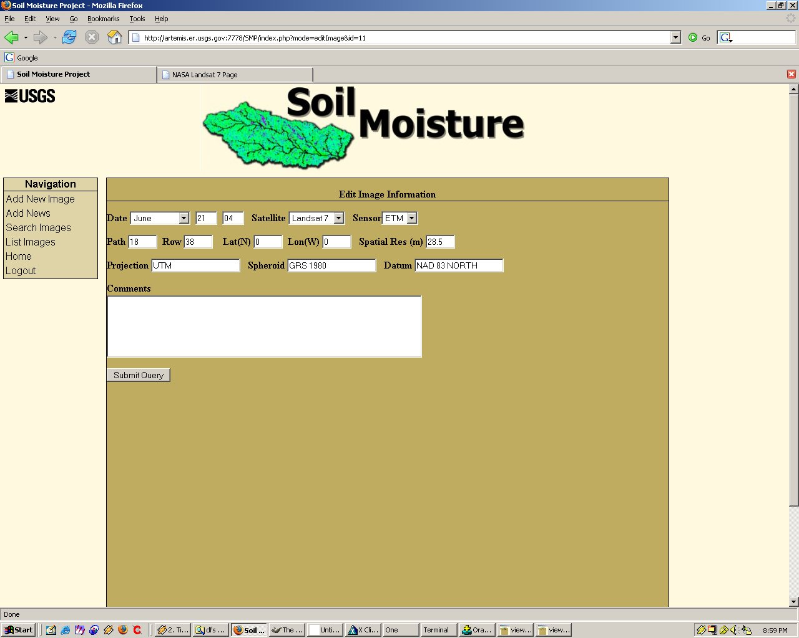

If the user sees something that he/she wishes to change about this image, the “Edit” link can be clicked, which will allow the user to change any value associated with the image, displaying something similar to the above image.

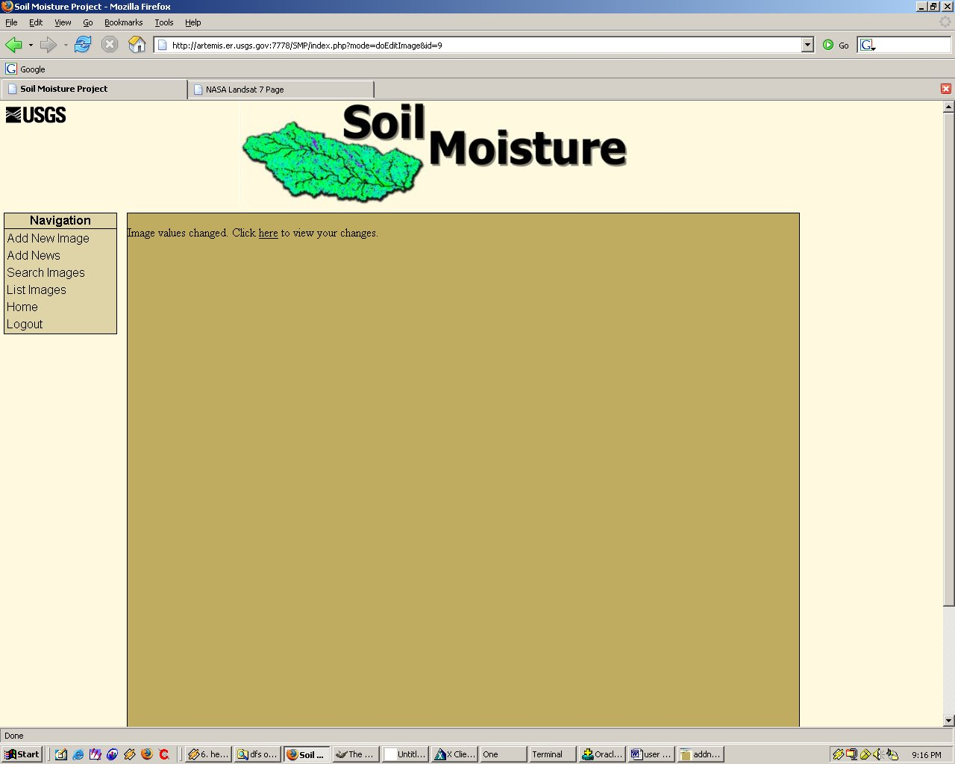

Upon submitting the new values for the image, a confirmation dialog is displayed, along with a link that will let the user view his/her changes.

The second way to get image data is by clicking “search” in the navigation bar. For instance, say the user wanted to search for every Landsat 7 ETM image in the database, the search page would look like this.

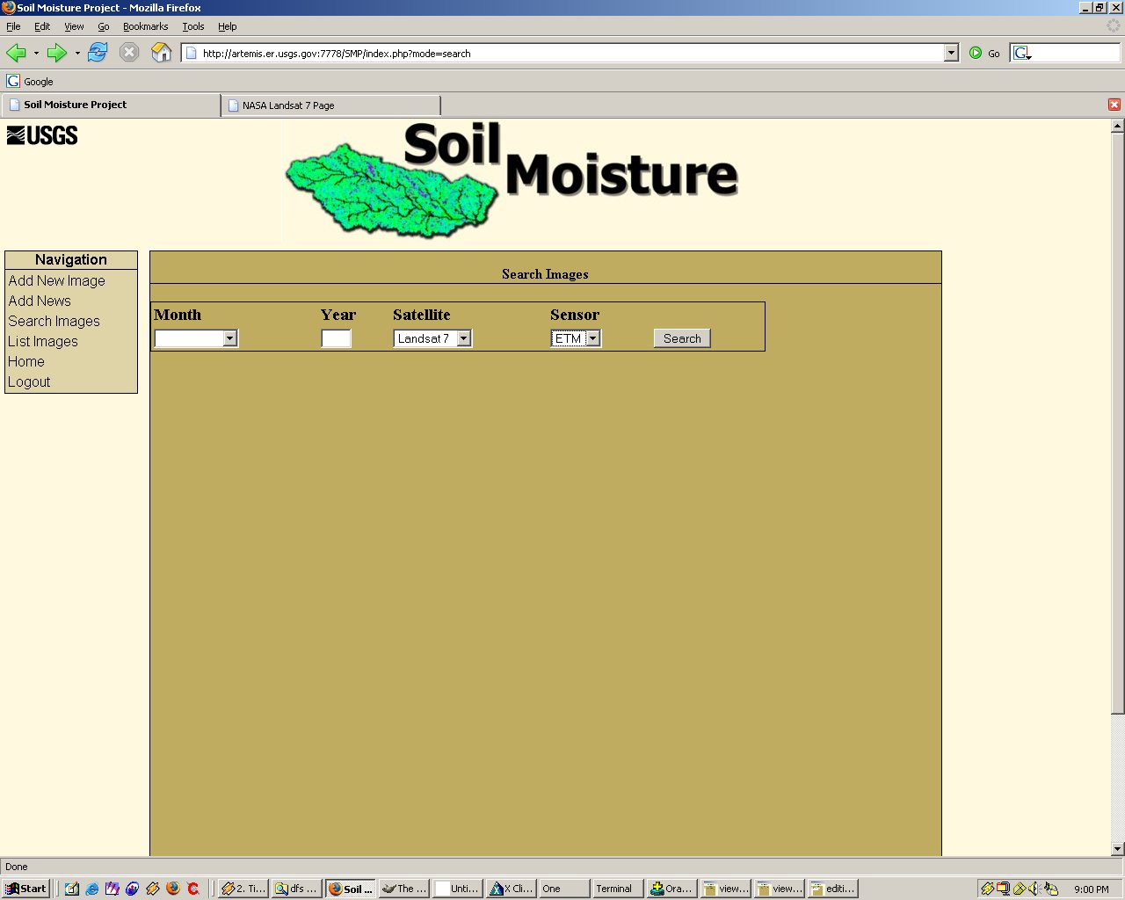

Once the user clicks search, a list of all matching images will be displayed.

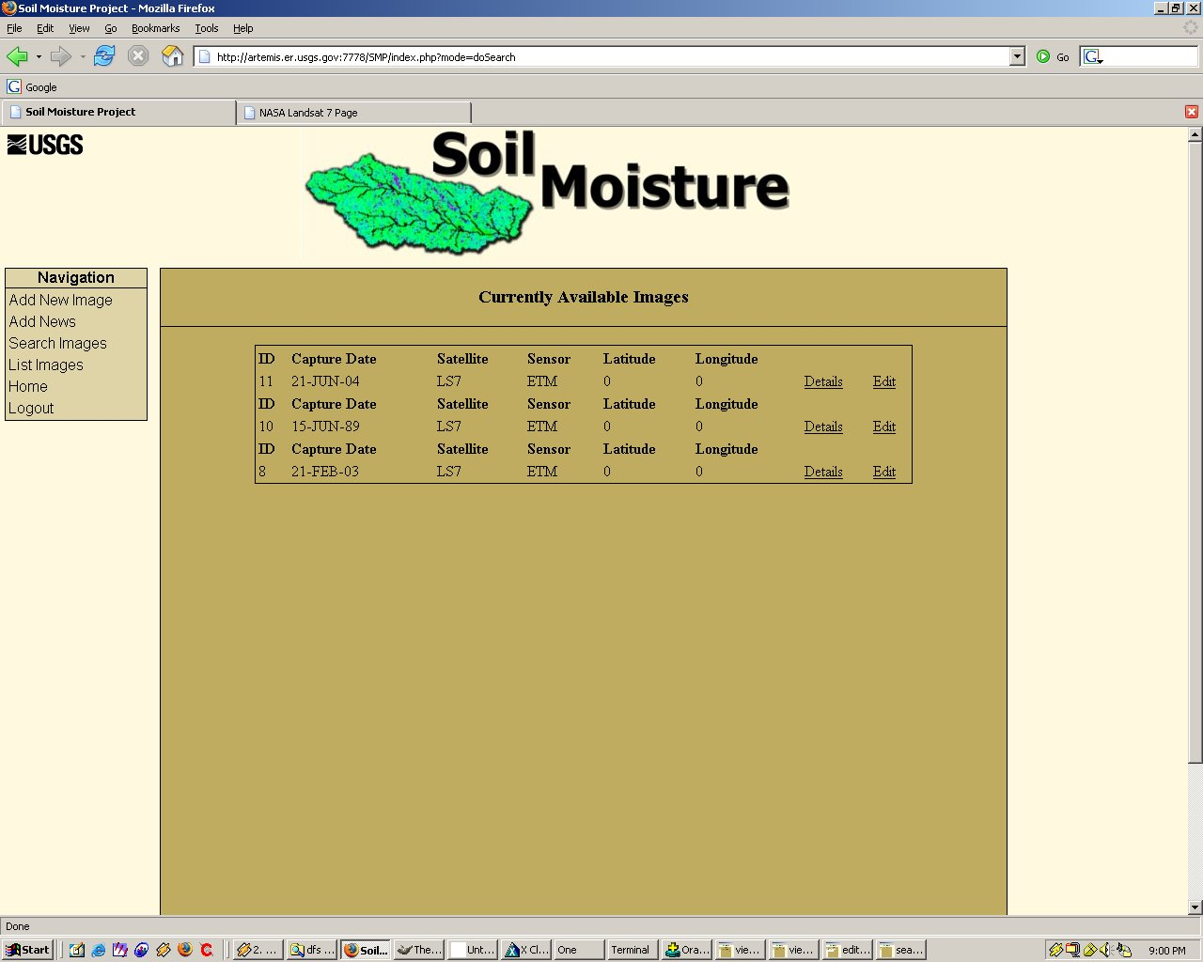

One thing that should be noted about using the search page is that when selecting different satellites, the list of available sensors will populate based on that selection. If, however, the user does not wish to only limit his/her search to one particular sensor, there is always a selection labeled “all” under the sensor selection box which will perform a search for every image matching the satellite field only.

